BLOGPOST - The Lean Approach: Minimum Viable Products

The Lean Approach: Minimum Viable Products
Video: https://www.youtube.com/watch?v=xxjbxk8dUqI

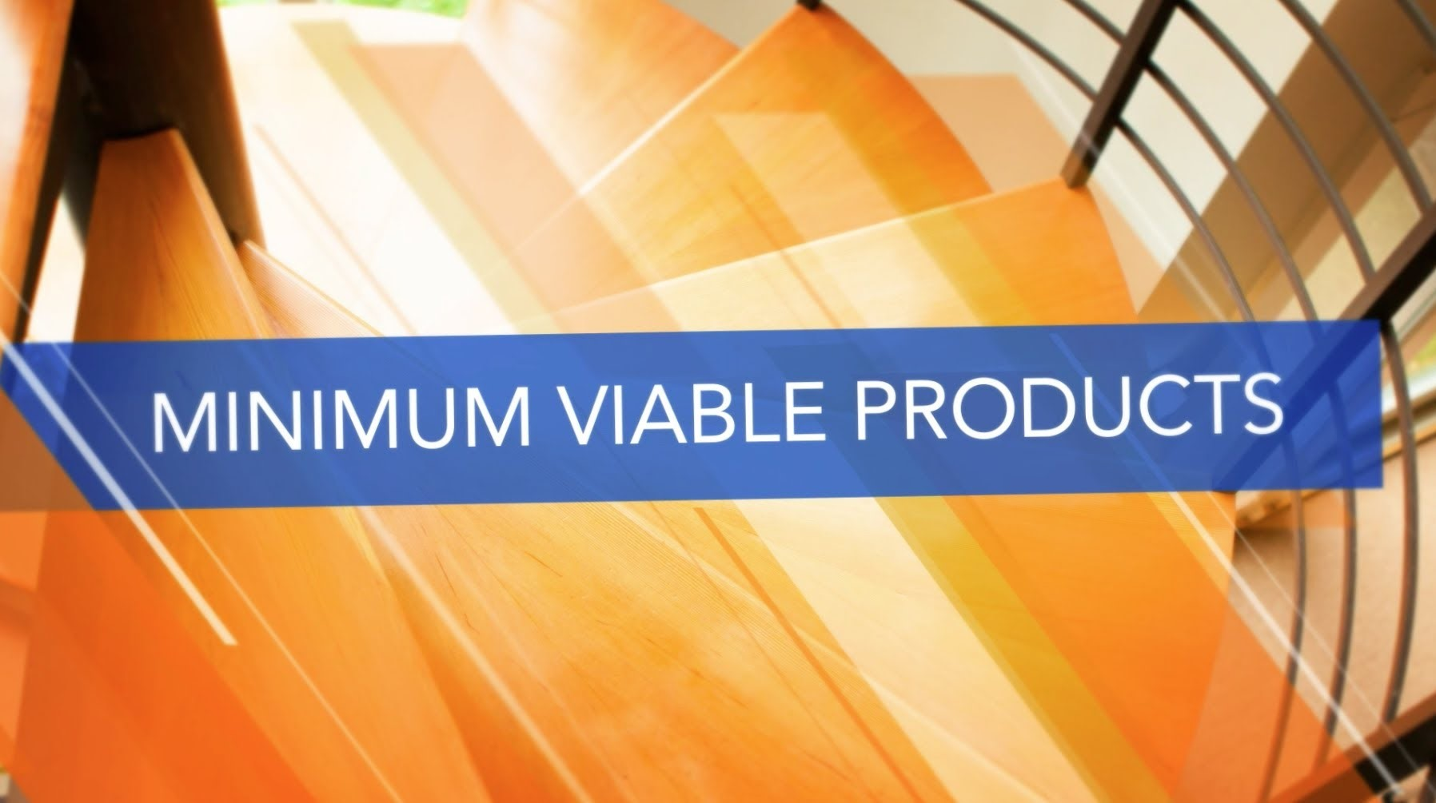

Description
Steve Blank says a minimum viable product, or MVP, can help you test your hypotheses about the market, and your customers, before you spend too much time creating and shipping the product.

THIS VIDEO CAN HELP ANSWER:
What is a minimum viable product?
Why should I create a prototype?
Do MVPs have to be perfect?
How can I use an MVP to run an experiment?

ABOUT THE KAUFFMAN FOUNDERS SCHOOL
Visit the website: [http://bit.ly/1EW2br7]
The Kauffman Founders School presents a powerful curriculum for entrepreneurs who wish to learn anywhere, anytime. The online education platform features experts presenting lectures in series modules designed to give Founders a rich learning experience, while also engaging them in lessons that will make a difference in their business today, tomorrow, and in the future.
The Kauffman Founders School series modules include Powerful Presentations, Intellectual Property, Founder's Dilemmas, Entrepreneurial Selling, Entrepreneurial Marketing, Surviving the Entrepreneurial Life, Startups, and much more.
© Ewing Marion Kauffman Foundation.

Aus <https://www.youtube.com/watch?v=xxjbxk8dUqI>

